CS235 HW4 - Teng Xu

1. (2 pts) Use the function is_luhn_valid to test whether Luhn algorithm catches single errors, and transposition of adjacent digits (except 09 and 90).

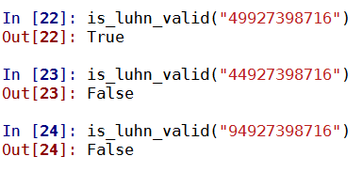

1. (4 pts) Define functions addCheckDigitUPC and addCheckDigitCC, which take as parameters UPC number and Credit Card account numbers and compute the check digit. In comments, write the formula by which you compute the check digits. Test the functions: the resulting number (with check digit) should be valid, verified by checkUPC from HW3 and is_luhn_valid from slide 18 of Lecture 3.

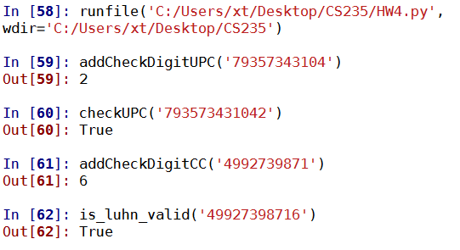

1. (4 pts) Define the functions encryptShiftCipher(message, key), decryptShiftCipher(message, key). Test them using examples from slides 6,7 of Lecture 4, and decrypting an encrypted message using the same key, which should return an original message.

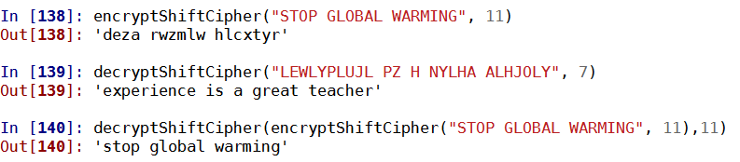

1. Suppose that when a long string of text is encrypted using a shift cipher, the most common letter in the ciphertext is X. What is the most likely value for the shift key? (Assume that the distribution of letters in the text is typical of English text, described at slide 9 of Lecture 4).

The most likely value is 19, because E:4 and X:23, 23 – 4 = 19.